HW2

Github: <https://github.com/ztjnwu/COEN241_Cloud-Computing>

**Tasks (70 pts)**

1. **Provide a screenshot of invoking the figlet function (5 pts)**

Solution:

The input is echo “Great!” | faas-cli invoke figlet, and the result is as follows.

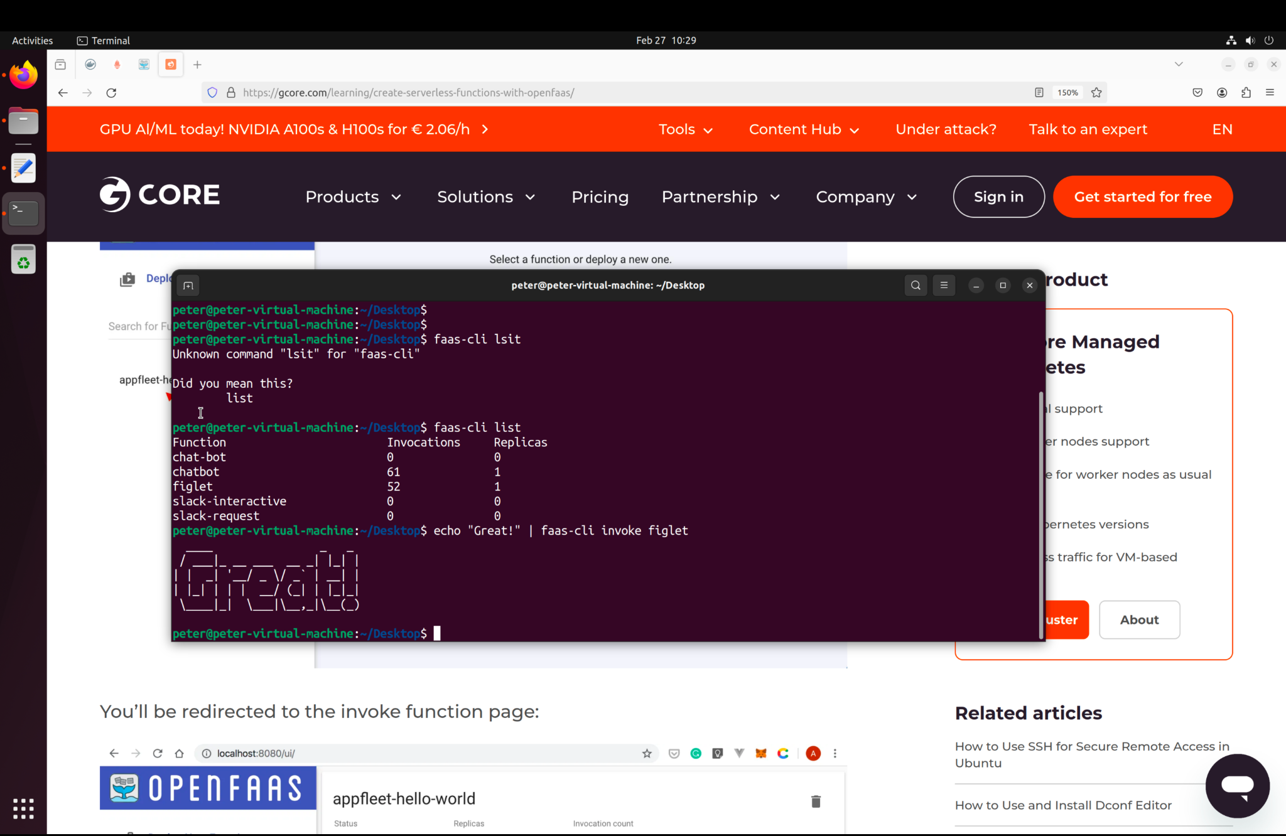

Fig 1. Output

1. **Provide a screenshot of running the following command (5 pts)**

**Sudo journalctl -u faasd --lines 40**

The result is as follows.

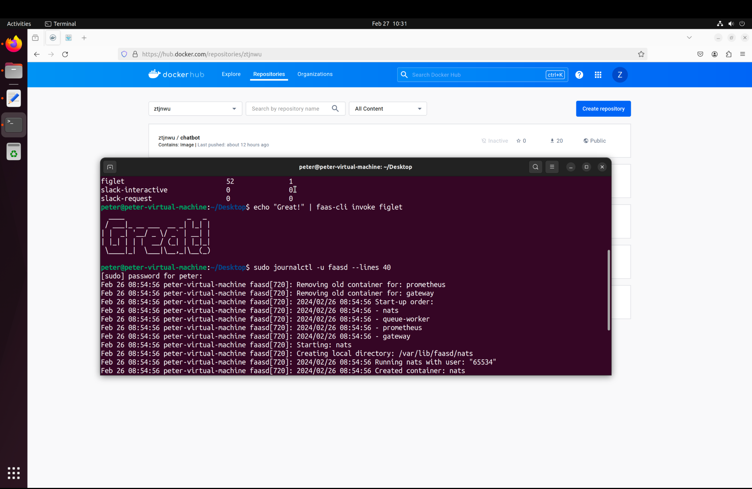

Fig 2. Output

1. **Complete slack-request/handler.py (10 pts)**

Here is the content of the file “handler.py”.

|  |
| --- |
| **import json**  def handle(req):  data = {  "text": "Serverless Message",  "attachments": [{  "title": "The Awesome world of Cloud Computing! COEN 241",  "fields": [{  "title": "Amazing Level",  "value": "100",  "short": True  }],  "author_name": "tengjiao zhu",  "author_icon": "",  "image_url": ""  },  {  "title": "About COEN 241",  "text": "COEN 241 is the most awesome class ever!."  },  {  "fallback": "Would you recommend COEN 241 to your friends?",  "title": "Would you recommend COEN 241 to your friends?",  "callback_id": "response123",  "color": "#3AA3E3",  "attachment_type": "default",  "actions": [  {  "name": "recommend",  "text": "Of Course!",  "type": "button",  "value": "recommend"  },  {  "name": "definitely",  "text": "Most Definitely!",  "type": "button",  "value": "definitely"  }  ]  }]  }  **return** json.dumps(data) |

Table 1. hadler.py

1. **Complete slack-interactive/handler.py (10 pts)**

Here is the content of the file “handler.py”.

|  |
| --- |
| **import json**  **import urllib**  def handle(req):  urlstring = urllib.unquote(req).decode('utf8').strip('payload=')  response = json.loads(urlstring)  data = {  "attachments": [  {  "replace_original": True,  "response_type": "ephemeral",  "fallback": "Required plain-text summary of the attachment.",  "color": "#36a64f",  "pretext": "Ahh yeah! Great choice, COEN 241 is absolutely amazing!",  "author_name": "",  "Author_link": "www.github.com/ztjnwu" ,  "author_icon": "",  "title": "COEN 241",  "title_link": "https://www.scu.edu/engineering/academic-programs/department-of-computer-engineering/graduate/course-descriptions/",  "text": "Head over to COEN 241",  "image_url": "https://www.scu.edu/media/offices/umc/scu-brand-guidelines/visual-identity-amp-photography/visual-identity-toolkit/logos-amp-seals/Mission-Dont3.png",  "thumb_url": "https://www.scu.edu/engineering/academic-programs/department-of-computer-engineering/graduate/course-descriptions/",  "footer": "Slack Apps built on OpenFaas",  "footer_icon": "https://a.slack-edge.com/45901/marketing/img/_rebrand/meta/slack_hash_256.png",  "ts": 123456789  }  ]  }    **return** json.dumps(data) |

Table 2. hadler.py

1. **Provide a screenshot of your OpenFaaS gateway AFTER deploying figlet, slack-handler**

**and slack-interactive functions (5 pts)**

Solution:

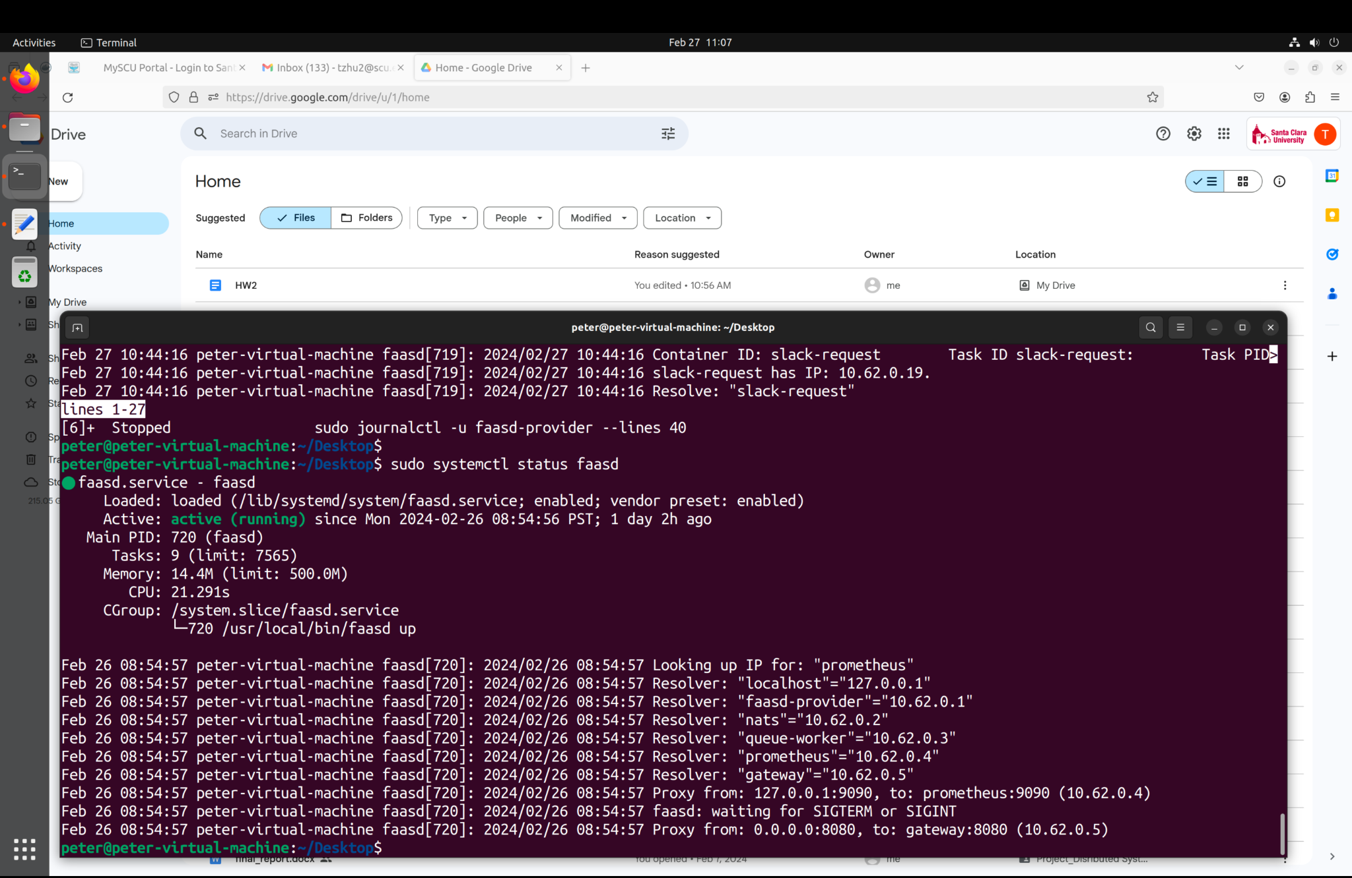

Fig 3. output

1. **Provide a screenshot of invoking slack-request and slack-interactive functions (5 pts)**

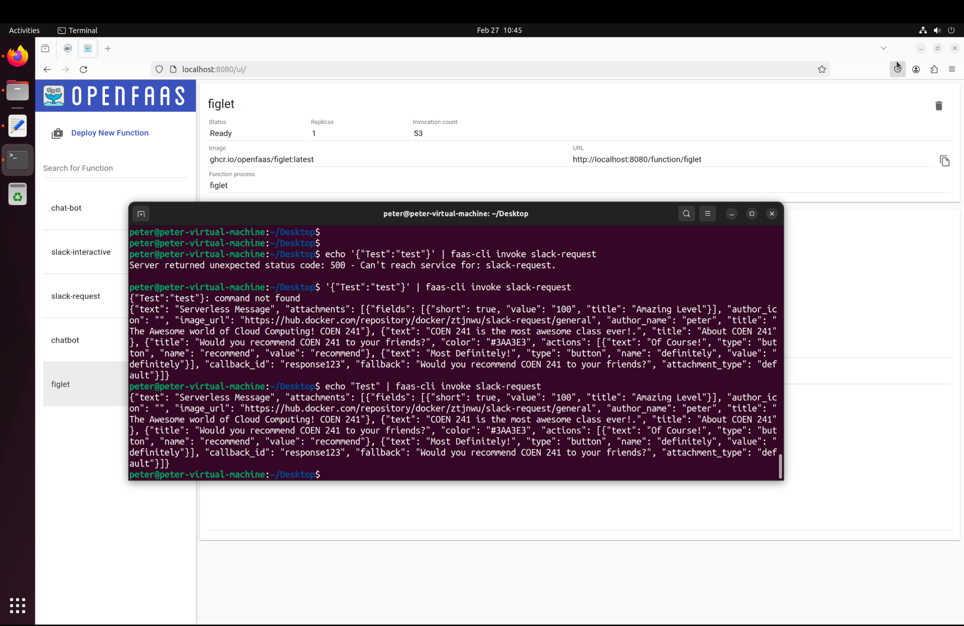

Fig 4. output

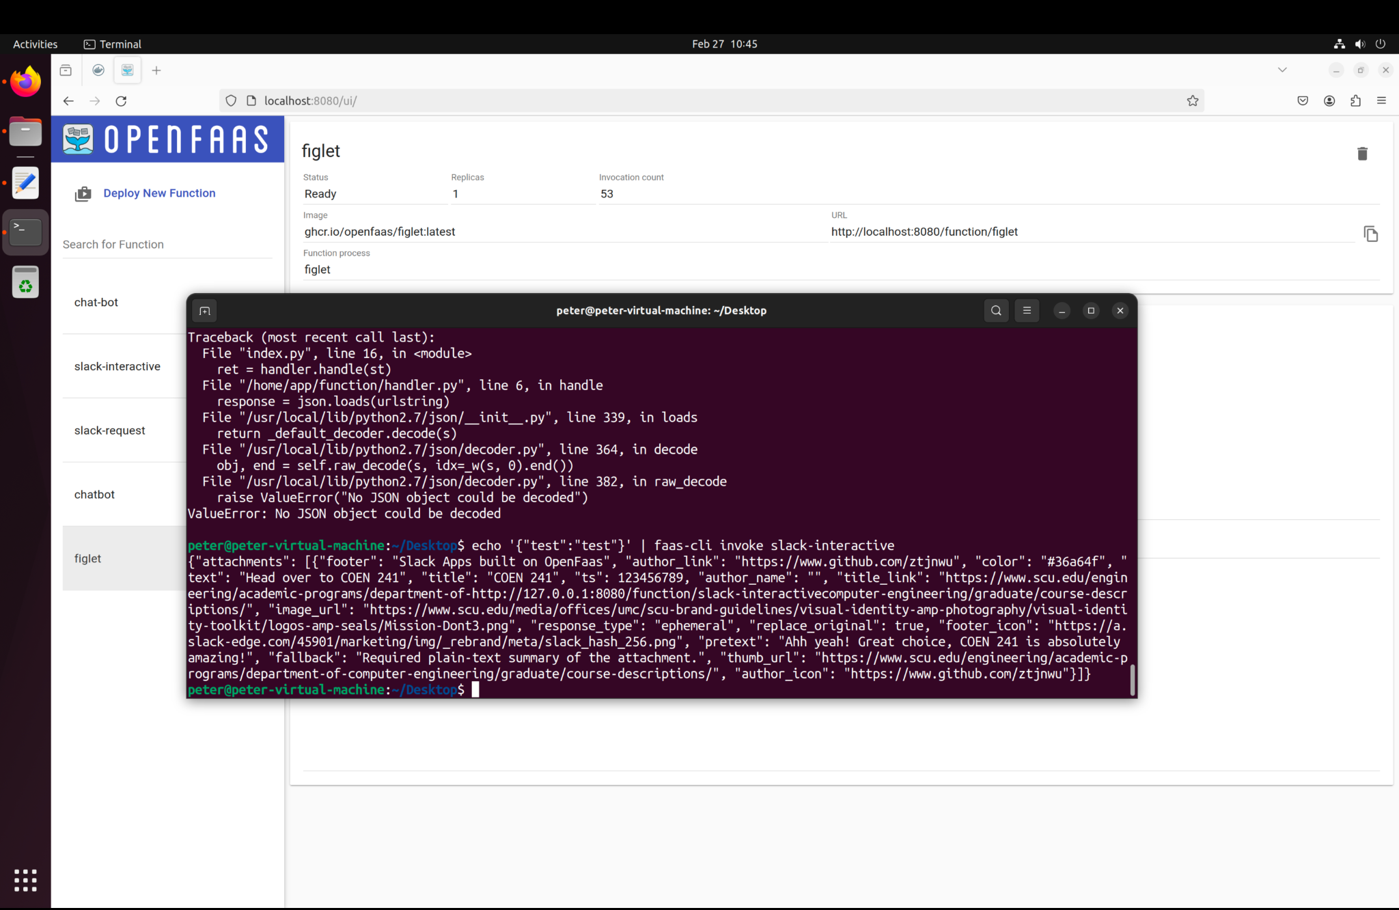

Fig 5. Output

1. **Complete the chatbot with a yml file (25pt)**

The chatbot consists of two parts including handler.py and chatbot.yml, which are

as follows.

|  |
| --- |
| **import json**  **import os**  **import re**  **from time import gmtime, strftime**  **import subprocess**  **import requests**  **def handle(req):**  #Get the data from user side  data = json.loads(req)  #Build the result for the query from a user  result = {}  **if** 'question' in data:  query = data['question']  if re.search(r'name', query):  result = "chatbot"  elif re.search(r'time', query):  result = strftime("%a, %d %b %Y %H:%M:%S +0000", gmtime())  else:  result = {"error": "Invalid request payload"}  **elif** 'figlet' in data:  query = data['figlet']  url = f'http://10.62.0.5:8080/function/figlet'  response = requests.post(url, data=query)  result = response.text    **else**:  result = {"error": "Invalid request payload"}    #Print  print(result)  #Return  **return** |

Table 3. Handler.py

|  |
| --- |
| version: 1.0  provider:  name: openfaas  gateway: http://127.0.0.1:8080  functions:  chatbot:  lang: python3  handler: ./chatbot  image: ztjnwu/chatbot:latest |

Table 4. chatbot.yml

1. **Provide a screenshot of invoking three different cases of the chatbot (5 pts)**

Solution:

1. The input is echo ‘{“question”: “name”}’ | faas-cli invoke chatbot, the result is

as follows.

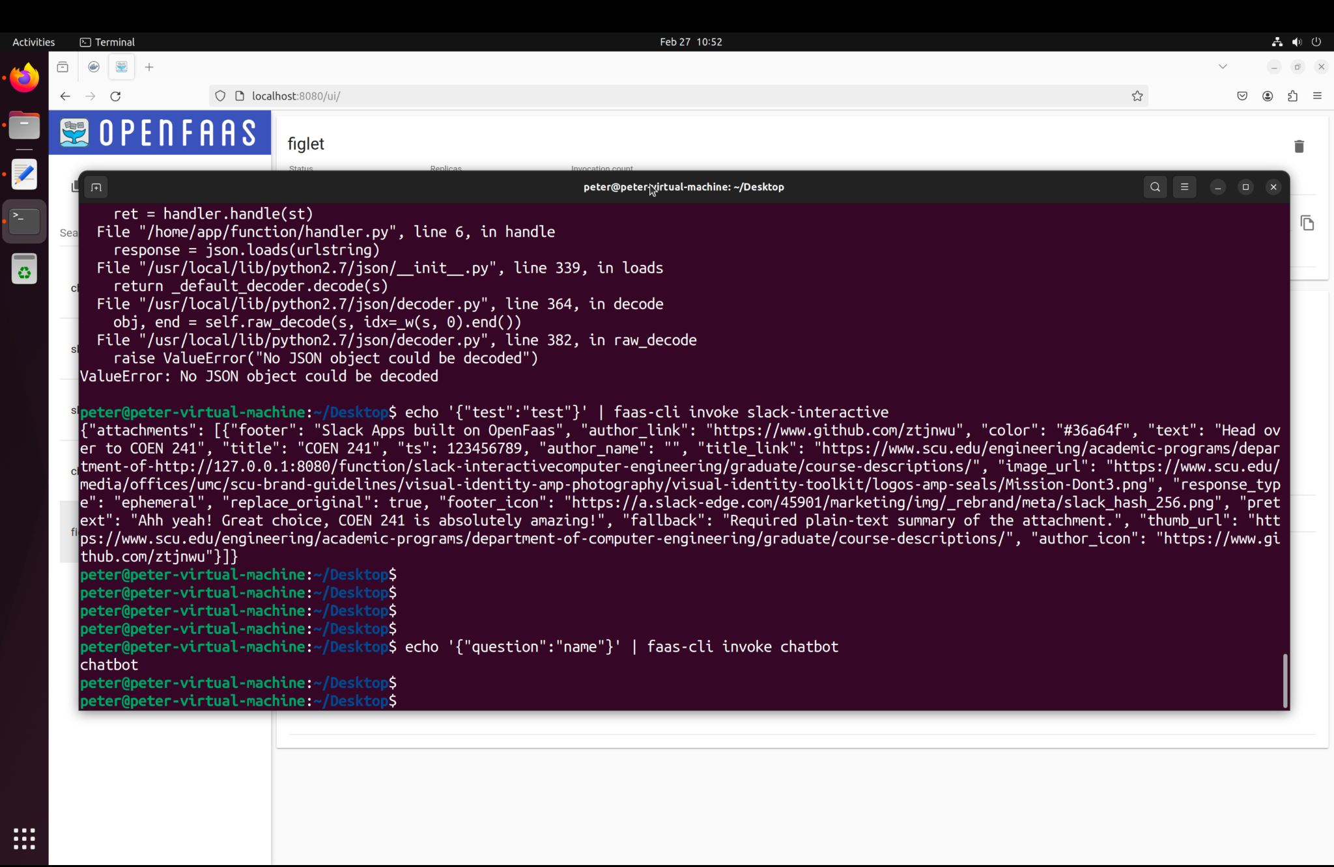

Fig 6. Output

1. The input is echo ‘{“question”: “time”}’ | faas-cli invoke chatbot, the result is

As follows.

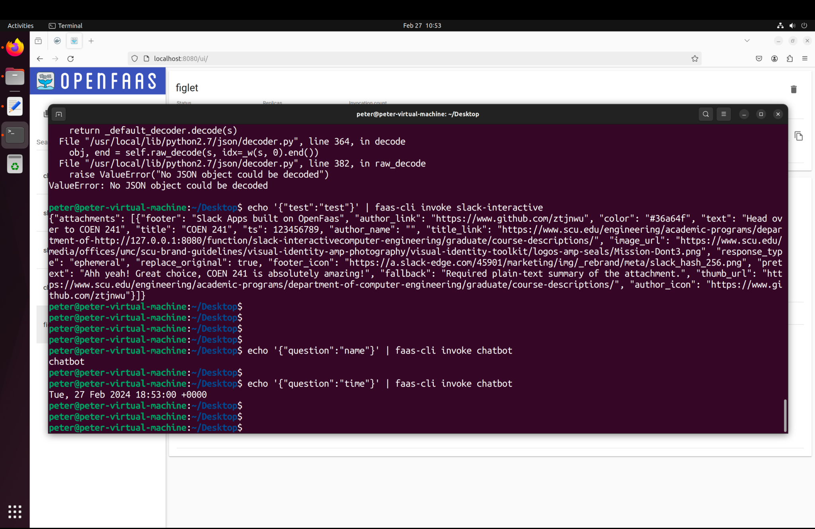

Fig 7. Output

1. The input is echo ‘{“figlet”: “Great”}’ | faas-cli invoke chatbot, the result is

As follows.

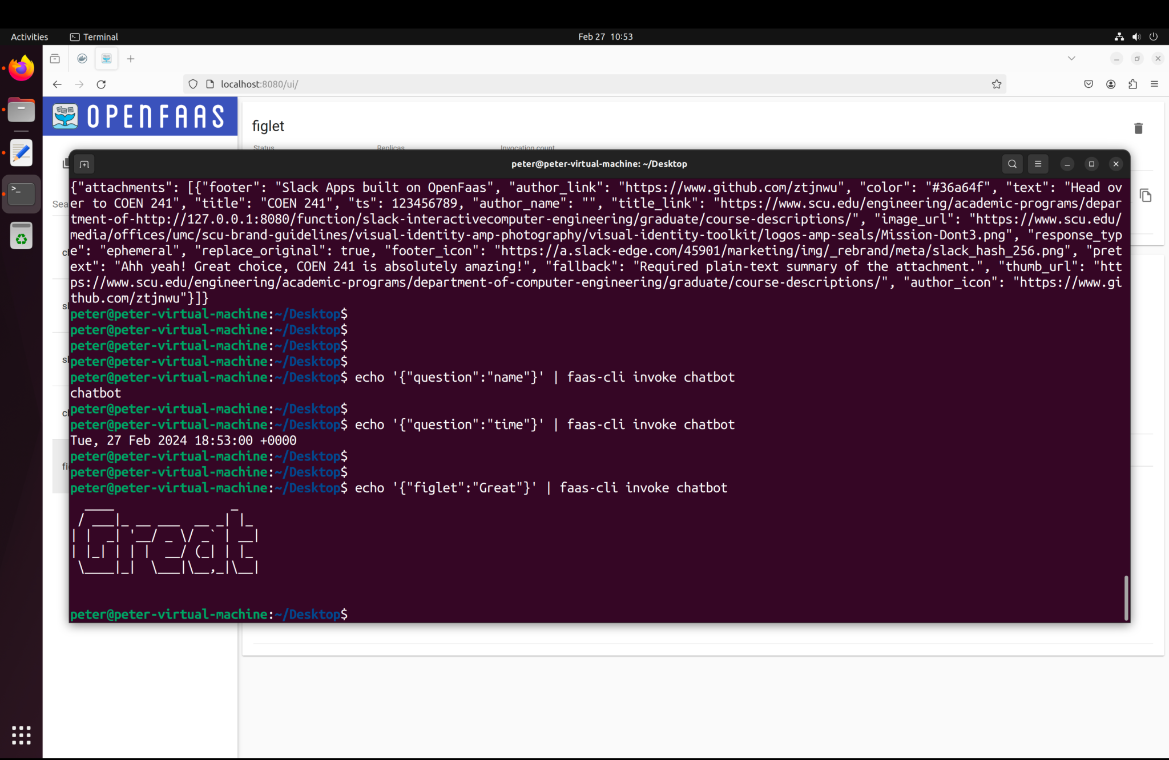

Fig 8. Output

**Questions (30 pts)**

**1.What is the command to invoke the slack-request function (2 pts)?**

1. Via Curl

**Curl** [**http://localhost:8080/function/slack-request**](http://localhost:8080/function/slack-request) **-d “Test”**

1. Via faas-cli

**Echo “Test” | faas-cli invoke slack-request**

**2.What is the output you see when you invoke the slack-request function? (2 pts)**



**3**.**What is the command to invoke the slack-interactive function? (2 pts)**

1. Via curl

**Curl** [**http://localhost:8080/function/slack**](http://localhost:8080/function/slack-request)**-interactive -d ‘{“Test” : ””}’**

1. Via faas-cli

**Echo ‘{“Test” : “”}’ | faas-cli invoke slack-interactive**

**4.What is the output you see when you invoke the slack-interactive function? (2 pts)**



**5**.**How would you pass different arguments to the functions? (3 pts)**

Solution:

One way to pass different parameters to a function is to use json data structure as input because

it can contain different variables.

**6**.**How would you change the slack-interactive function to react to different inputs? (3 pts)**

Solution:

One way to achieve the goal is to add more key-value pairs to the file handler.py. If the given parameters from the input are in the data of type json, the function **handle(req)** returns the corresponding values.

**7.How long does it take for the chat response to come back? (10pts)**

1. For the first request that does not call figlet

|  |  |
| --- | --- |
| **Input** | **Round-trip time** |
| “{“question”: “name”}” | 0.499 |

1. For the second request that does not call figlet

|  |  |
| --- | --- |
| **Input** | **Round-trip time** |
| “{“question”: “time”}” | 0.391 |

1. Average over 10 requests that do not call figlet

|  |  |
| --- | --- |
| **Input** | **Round-trip time** |
| “{“question”: “name”}” | 0.499 |
| 0.372 |
| 0.353 |
| 0.362 |
| 0.343 |
| 0.345 |
| 0.364 |
| 0.35 |
| 0.362 |
| 0.38 |

Therefore, the average round-trip time is 0.373 second / request

|  |  |
| --- | --- |
| **Input** | **Round-trip time** |
| “{“question”: “time”}” | 0.369 |
| 0.36 |
| 0.362 |
| 0.36 |
| 0.371 |
| 0.372 |
| 0.377 |
| 0.373 |
| 0.371 |
| 0.385 |

Thus, the average round-trip time is 0.37 second / request

1. For the first request that calls figlet

|  |  |
| --- | --- |
| **Input** | **Round-trip time** |
| “{“figlet”: “Great”}” | 0.413 |

1. For the second request that calls figlet

|  |  |
| --- | --- |
| **Input** | **Round-trip time** |
| “{“figlet”: “Great”}” | 0.365 |

1. For the second request that calls figlet that follows the first request that does not call figlet

|  |  |
| --- | --- |
| **Input** | **Round-trip time** |
| “{“question”: “time”}” | 0.374 |
| “{“figlet”: “Great”}” | 0.356 |

1. Average over 10 requests that do call figlet

|  |  |
| --- | --- |
| **Input** | **Round-trip time** |
| “{“figlet”: “Great”}” | 0.356 |
| 0.364 |
| 0.364 |
| 0.382 |
| 0.38 |
| 0.371 |
| 0.392 |
| 0.381 |
| 0.378 |
| 0.384 |

As we can see in the table above, the average round-trip time is 0.375 second / request

8.Now try sending a series of requests to the chatbot in parallel.

At what queries per second does OpenFaaS add a new instance of the function? (6 pts)